ECE Class Kit Vending Machine  
Project Proposal

Nidhay Patel   
Department of Electrical and Computer Engineering  
*Tennessee Technological University*   
*Cookeville, United States of America*  
*npatel45@tntech.edu*

Austin Sigg  
Department of Electrical and Computer Engineering  
*Tennessee Technological University*   
*Cookeville, United States of America*  
*aesigg42@tntech.edu*Dillon Williams  
Department of Electrical and Computer Engineering  
*Tennessee Technological University*   
*Cookeville, United States of America*  
*dswilliams42@tntech.edu*

Ryan Reed  
Department of Electrical and Computer Engineering  
*Tennessee Technological University  
Cookeville, United States of America*  
*rcreed42@tntech.edu*Michel Turpeau  
Department of Electrical and Computer Engineering  
*Tennessee Technological University  
Cookeville, United States of America*  
*mmturpeau42@tntech.edu*

# Introduction

Every year hundreds of students require devices for their ECE classes. These specific devices are provided by the College of Engineering and are rented out to students through the ECE office. Typically, in the first month of a semester, a significant number of students attempt to check out devices from the office. This capstone project will focus on designing and implementing a vending machine that can check devices out to students while recording which students have checked out a device.

The finished product will be a vending machine that is able to vend devices to students. A student can enter their information and the machine will record who has checked out the device. The machine will include a clear front panel, which allows students to see and determine which board they need. A platform will lift to the desired device and vend it to the student.

The ECE office will benefit from having this machine because it will reduce traffic in the ECE office. It will also ease the process for the students because they will not have to fill out paperwork. Instead, the vending machine will allow the office to view the data submitted by the students. Because of this, the office associates will have to fill out paperwork on students less frequently, and the machine will remember the data students enter.

The first prototype will have the ability to prevent boards from getting stuck, have a touch interface for students to enter information on, have a locked door to enable associates to refill the machine, and have memory in the event of a fault or power loss to remember its functionality. The machine will also be fitted with a method of communication in order for the associates to pull student information from it. Security will be implemented in order to prevent boards from being stolen and to protect the database.

The objective of this capstone project is to make the process of checking out devices for ECE courses simpler by utilizing a vending machine, while also recording all information given by a student through a database.

# Formulating the Problem

This section will introduce the background information needed for the project. This includes the constraints and

specifications of the machine and the standards we will be bound to when working on the project. A survey of possible solutions to the problem will also be given so the project can be further improved in the future.

## Background

Much of the project relies on the background information of the systems in vending machines, and how they operate. The project will require knowledge in the areas of controls, programming, embedded, power, databases, and others.

Vending machines are used throughout many businesses and are a great source of convenience for the customers who use them. Maintenance on well-made vending machines is also low, saving time for the business as well [1]. A vending machine for the class kits in the ECE office would be of great convenience to students who can come by and pick up a device. It would eliminate the need to fill out paperwork in the office to obtain a board, as well as allow the office associates to do their own work without worrying about the students.

The project that is desired is difficult enough to allow for multiple people to assist in the creation of the machine. The machine requires its own control and power system to operate correctly. It must also have a computing system to control the platform and motors to dispense the board for the student. For the office to know who has retrieved a board, the machine must also have an onboard database system that is able to keep track of students and communicate with the office associates. The machine also requires some type of security to avoid student information being stolen and physical security such as a lock to protect the devices. The reason we do not require a machine that is “off the shelf” is that all current vending machines drop the items to the bottom. The devices in the ECE office are sensitive and prone to breaking if dropped from a height. Also, most vending machines are paid services requiring the customer to buy the product whereas ours is for renting the product without a charge. Our team of engineers is in charge of the design of electrical and computer systems, and the mechanical team is in charge of the actual machine. Our part of the project cannot be bought and requires design.

The objective of the class kit vending machine is to have a machine that is capable of recording student and class information and using that information to know which device is required for the student. Then the machine can properly retrieve and distribute the device to the student and record that the student has the device for the department. In order for the machine to accomplish its given task, a power system, microcontroller, sensors, motors, student database, controls, interface, and possibly PLC systems.

The proposed power system for the machine would utilize a 120 W AC to DC converter as its source. The converters can range in output from 12 volts DC to 54 volts DC and need to be high efficiency to avoid overconsumption [2]. A benefit of a high-efficiency power supply is the machine remains cooler, increasing the machine’s lifetime [2]. Extra Fuses will be included to ensure the voltages of the devices are not exceeded as another protection layer. If needed, the team may also include a backup supply in case the system fails.

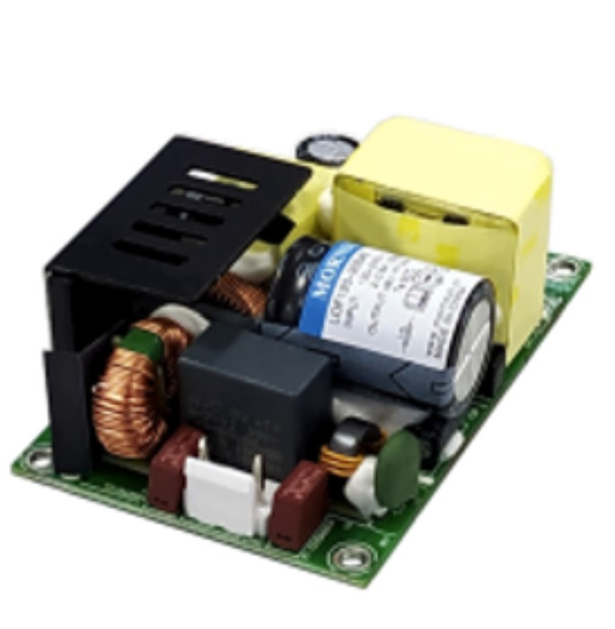

*Figure 1: 120W Power Supply*

The machine requires a microcontroller/computer to control the electronics inside and to hold a database that keeps track of each student who has obtained a board. The computer will also control the interface on the machine that the student needs to be able to take a device and possibly control a card reading device.

For vending the devices, the team has ideas on what type of motor to use. One option is to use normal vending machine parts such as the coils with stepper motors. Another is a belt and gate which moves only the device that has its gate opened. Either option will require the team to use a platform that can raise and lower to retrieve the device for the student.

## Specifications

The class kit vending machine must follow several specifications to achieve the customers’ desired objectives. First, the team must prevent the devices from getting stuck in the machine. However, normal machines are prone to having products become stuck, which results in people shaking and possibly damaging the machine [3]. The machine must be large enough to accommodate any device the department must put into the machine as well.

Secondly, the customer requires that the machine have some form of communication so the information can be retrieved from the machine. Most vending machines communicate through telemetry, which allows the machine to connect to the internet [4]. Some machines that are connected to the internet are vulnerable to hacking and can cause issues with other devices, which is why the team is considering alternate methods [5].

The vending machine must be able to keep track of a student’s Tech email, name, ID, and class according to the customer. In order to know what device is checked out, it must also know which board number is taken, which the student must enter after getting the device. An interface is required on the machine for the student to enter board numbers into the database as well after vending.

The machine requires a fault option if power is lost, and must remember what was entered before power loss. Security must also be applied to avoid any student stealing a board out of the machine after power loss, which will most likely be a type of lock. Lastly, the machine must be large enough to fit a decent number of devices before requiring the office associates to refill the machine.

## Constraints

The vending machine must follow certain constraints in order to be properly designed for the ECE office. The machine will be plugged into the wall, and must, therefore, follow the national electric code in order to be allowed to be used. The national electric code of the United States is the NFPA 70, which is the benchmark for the safe design and installation of electric devices [6].

The machine must not be as large as a normal vending machine because it must fit inside the ECE office without obstructing the work environment. Also, for communication purposes, if Bluetooth is used, it can only operate on a 2.4 GHz frequency in order to avoid conflict with wireless networks [7].

The team must also adhere to student data privacy regulations from the school and apply measures to the machine in order to prevent any name or ID leaks.

## Standards

To ensure our team can successfully and safely implement our vending machine, we must understand the standards under which the machine will have to comply. These standards come from both IEEE and the government, and we must comply with both.

One of the most important standards we must hold to is the National Fire Protection Association 70 (NFPA 70), also known as the National Electric Code (NEC). This standard covers a large portion of our safety regulations; installations of connections, circuit protection, wiring, and general-purpose equipment such as cords, receptacles, and switches. This standard also covers the installation of electrical conductors and equipment “…used by the electric utility, such as office buildings…that are not an integral part of the generation plant…” [8]. These regulations are just the surface of the NFPA 70 standard. Our team must familiarize ourselves with this standard, above all, in order to successfully implement our vending machine.

Another standard similar to the NFPA 70 that we must comply with is the IEEE C2-2023 code. This code is similar to the NFPA 70, in that it involves standards related to those covered in the NFPA 70. IEEE C2-2023 is the National Electrical Safety Code(R) (NESC(R)) that “…includes the work rules for the operation of electric supply and communication lines and equipment,” [9]. This is a standard that covers more specific elements of working with the electrical communication and wiring rather than being an overall standard for all things electrical, like the NFPA 70.

Finally, one more standard we must comply with is IEEE Policy 7.8. This is the Code of Ethics that any electrical and computer engineer must comply with in order to conduct any professional work. This code of conduct requires that all engineers “uphold to the highest standard of integrity, responsible behavior, and ethical conduct in professional activities,” and “to treat all persons fairly and with respect, to avoid harassment or discrimination, and to avoid injuring others,” [10]. While IEEE Policy 7.8 does not cover anything involving electrical work specifically, it is a crucial standard we much adhere to. Without this policy, there is no guarantee that a project will be ethical or safe for the public. It also helps our team members keep each other accountable for upholding good ethics.

## Survey of Possible Solutions

Because the use of vending machines is such common practice, there are several possible solutions out in the market. One option is the smart vending machine. The smart vending machine would be a reasonable solution to our problem because of its convenience. A smart vending machine implements a touchscreen and digital transactions in order to become a more service-oriented machine [11]. This would help solve the issue of convenience for the ECE office and the student. In a non-smart vending machine, buttons can get jammed and lock up.

Another possible solution to our problem is an elevator vending machine. The general snack vending machines use a coil to keep their products on the shelves and when a product is requested, it will drop down into the collection bin. An elevator vending machine has a platform that raises to the desired level and the product is pushed onto it via a conveyor belt or a gate [12]. The product is then lowered down into the collection bin rather than being dropped. This is another possible solution to our problem because we cannot drop the devices used in the labs; these kits and devices can be very fragile and even a small fall could severely damage them.

One final solution that could be implemented is an array of lock boxes. The team we are collaborating with suggested using a series of lockboxes that could be refilled. When a student wants to check out a specific board, they would have that door unlocked and the staff would refill it. Our team believes that this solution could work, but it would have to be refilled more frequently than a regular vending machine. We also believe that a series of lockboxes would take up significantly more space than a vending machine.

## Summarizing the Problem

The existing solutions for our problem statement do not meet the specifications that we desire. At least, not on their own. The vending machine for the ECE office should have a customer-friendly interface, such as that of the smart vending machine. Our vending machine should also have a lift and conveyor to safely dispense the kits, such as that of the elevator vending machine. Given our background information, specifications, and constraints, our vending machine should be able to communicate through telemetry, safely and securely dispense the kits and boards, store and protect the information entered by each student, and reliably restart when there is a power outage. No lone vending machine that is available now can fill all of these specifications, and that is why our project is important to the ECE Department.

# Looking Toward a Solution

This section of the proposal will outline how the team will start crafting a solution based on the current problem. To be able to craft the solution, the team must determine the critical unknowns of the project. The team will attempt to measure the success of the solution as well as provide proof of the success with different experiments. The broader impacts, ethics, responsibilities, and the scope of the class kit vending machine with a proposed solution to creating the machine.

*A. Systems*

The following diagram relays the proposed layout of the systems within the machine. Some of the systems will include the power, sensors, motors, MCU, and mechanical system. The mechanical system will be designed by the mechanical senior team, with the rest left to ours. The power system will focus on the voltage level of components and the system that will be plugged into the wall. The sensor system will mainly consist of tracking the level of the platform that will vend the devices. The MCU system will consist of the computer PCB and the system to send messages to the motors of the machine.

*B. Critical Unknowns*

One of the most important unknowns that we must account for is a potential power outage. This is important to understand because if there is a power outage and the vending machine does not have memory, it will forget its previous state and the commands thereafter. This is one of the worst-case scenarios for our machine since it could forget who has checked out a board and the type they checked out. The safety measure that our machine will have implemented is non-volatile memory. Having this memory will allow the vending machine to remember and reboot its previous state in the event of a power outage.

Another critical unknown for the machine is the security of the database. This is sort of dependent on how we decide to communicate with the ECE office. If the communication is through Bluetooth or Wi-Fi, someone using a program such as Wireshark could access the data that is being transmitted. This is a very big issue because the students’ information needs to be held private and secure. One way we can take a countermeasure is by using Ethernet to communicate instead of Bluetooth or Wi-Fi. It is significantly harder to access data being transmitted if it is through a wired connection such as Ethernet.

A final critical unknown that could occur is a surge. Not necessarily a power outage, but a current overload in the power system. This could cause a shortage in the vending machine circuit and ruin its functionality. A countermeasure to this could be a surge protection circuit added to our AC power intake. Though it may not fully prevent damage from a surge, it can help mitigate the damages.

## C. Measurements of Success

To properly observe and measure the progress of this project, there are methods of validation placed along the track. These will not only better show the progress achieved over time, but they are also a good way to plan out and strategize our next moves. Working with these constraints and problem solving the unknowns to mark success.

In its ideal form, the system would be able to process the user’s inputs and dispense the requested device post-haste. To achieve this, specific requirements are needed for the processing power of our main controller and the potential speed of the lift and belt motors. There is also the need to consider a reasonably safe speed for the mechanical components, and the proper power that needs to be supplied. Efficiency, while a top priority, will not take president over safety.

Since this device will mainly be utilized by consumers, the system must have an intuitive system. to be intuitive. To measure success, periodic user tests will assess the ease of use and examine any complications or bugs. These tests will be performed by both future operators and potential customers.

Another way to measure success will be to progress the microcomputer and its data storage and transfer capabilities. As well as its practicality for both students and operators. There will also be testing for the security of the data stored, using "unorthodox" methods to check the difficulty of breaching the system.

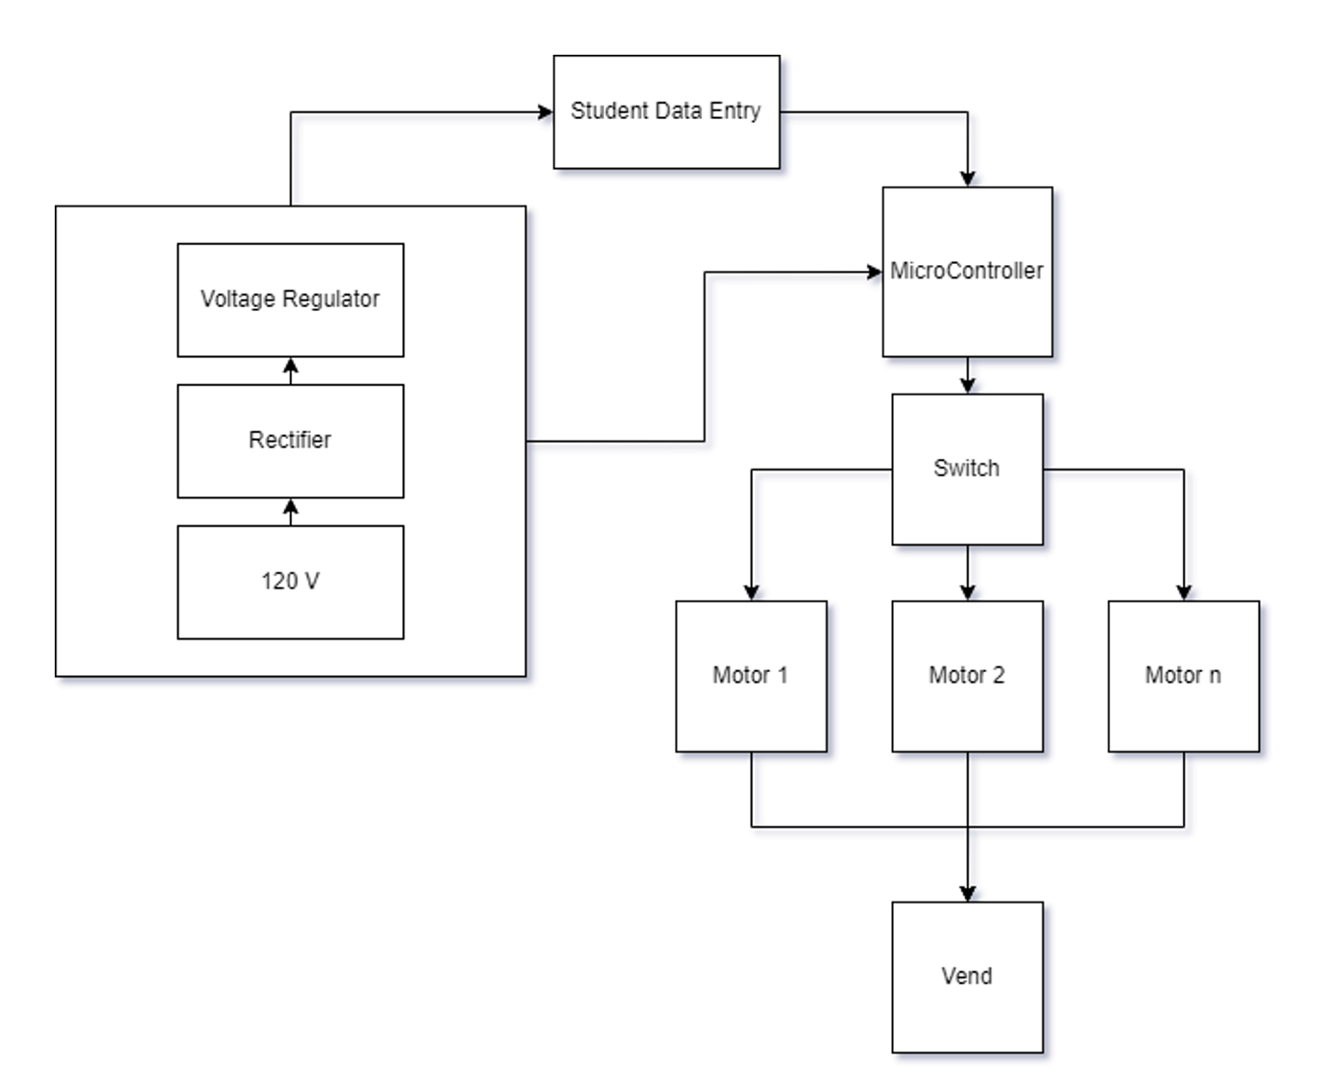

*Figure 2: Formulated Layout of Machine*

## D. Impacts, Ethics, and Responsibility

Normally with design projects, there are certain negative impacts that can arise. Our design will not displace any workers on the campus because the machine is meant to make the office associates’ jobs easier. The machine will allow students to get a board without interrupting the associate’s work. The only requirement from the associate is to refill the machine when it is low on its stock. This means that no jobs will be affected by the introduction of the machine. The machine has the potential to take some load off of the office workers as well.

The main impact associated with the vending machine is the risk of a fire. The machine will need to go through heavy testing in order to ensure that the machine cannot fail and cause a fire at the college. The machine must have a fully redundant power system in order to avoid causing a fire. The plan is to have a backup power system in parallel with the primary in order to have a way to shut off a system if it fails. Also, fuses will be included as an extra precaution. Another concern is the safety of data held within the system on the machine. If someone was able to hack the database, students’ IDs, names, and emails would be available to use for any purpose. The team will attempt to keep the machine off of the Wi-Fi network to avoid hacking attempts. No device should be stolen because the machine will be kept inside the office. The power system must also require low power when the machine is not in use, otherwise, the machine will be costly to the department.

# Resources

This section of the proposal addresses what resources are available and how they will be used throughout the design process. The team’s skills and knowledge will be discussed to demonstrate how the team is a good fit for the project. The proposed budget and timeline are attached to show how the machine can be finished in a reasonable amount of time.

## Personnel and Skills

To complete the design of the machine, our team must have the required knowledge. The team is not expected to be able to do the project without an issue, as not all knowledge will be available at the beginning, but the team is expected to be able to learn any new skills required.

In order to complete the vending machine, skills in databases, programming, power systems, PLC, controls, and microcontrollers are needed.

Dillon Williams and Nidhay Patel, both being Seniors in Computer Engineering, have skills in programming languages such as C++, C, and SQL, which are required in order to program the microcontroller and create the database to hold all student information, and knowledge of microprocessors, which is needed to manage system communications.

Ryan Reed and Michel Turpeau both are Electrical Engineering Majors with concentrations in Mechatronics. The concentrations give our team needed knowledge of automation and robotics, as well as controls. The concentration also provides a bridge between our team and the Mechanical team.

Austin Sigg is an Electrical Engineering major with knowledge of power systems and hands-on experience with wiring machines and programmable logic controllers just like Ryan.

With a wide variety of knowledge in programming, power, and ladder logic, our team is well suited to the creation of the vending machine, although there are areas that will require the team to acquire new skills.

## Budget

The budget for the class kit vending machine is subject to change throughout the design process. The suggested budget will function as an outline in order to prove that the project can be built at a reasonable cost. The project is given an error of fifteen percent to allow for an estimate of the possible range of cost. The budget of the possible components for the project is detailed in the figure below.

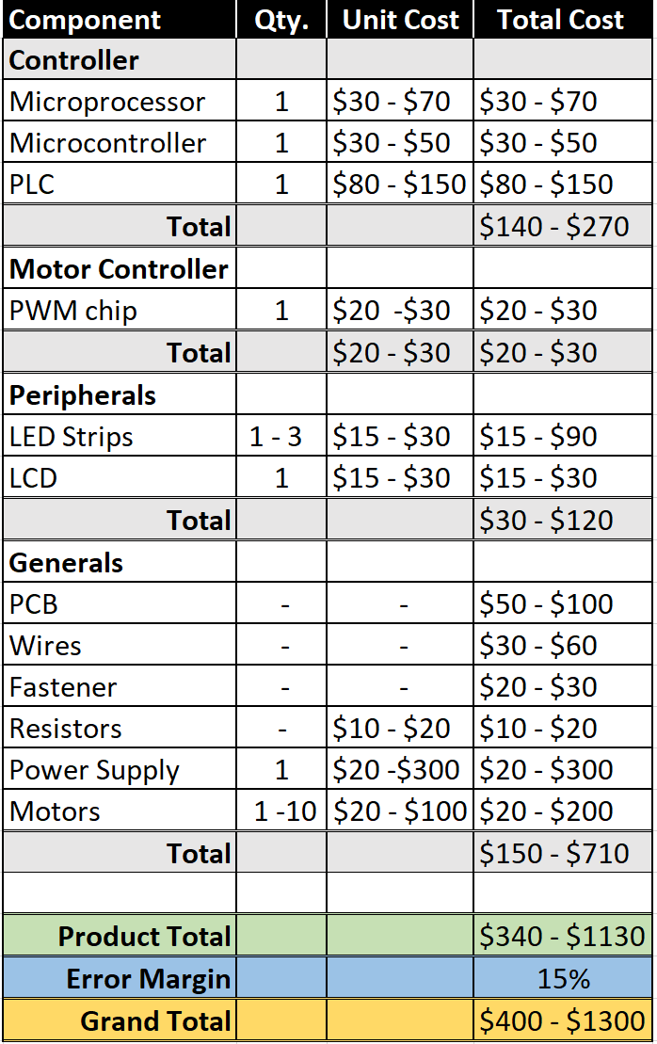

*Figure 3: Cost Breakdown*

## Timeline

The purpose of the project timeline is to lay out the deadlines for the different sections of the design process and to help the team stay on track to finish the design this semester.

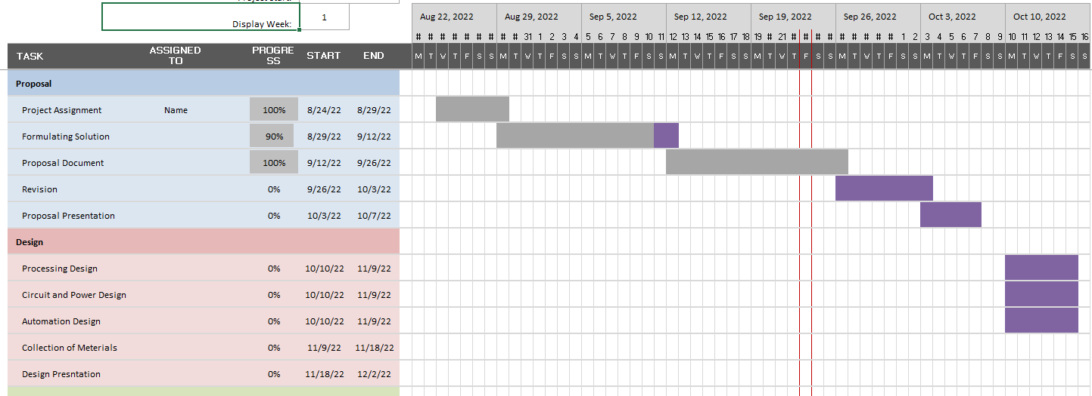

*Figure 4: First 8 Weeks*

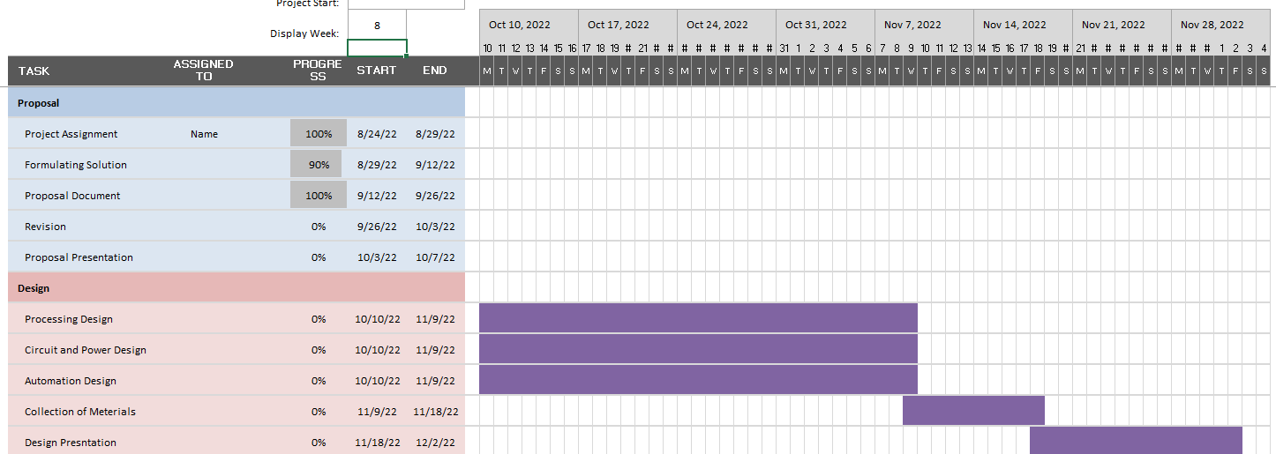*Figure 5: Last 8 Weeks*

# Conclusion

Sigg write this.

# References

1. Elisabeth, “Vending Machines have advantages,” Camelback Vending, 16-Jul-2018. [Online]. Available: https://camelbackvending.com/vending-machines-advantages/#:~:text=Vending%20machines%20are%20convenient%20and%20they%20allow%20your%20employees%20and,are%20in%20the%20right%20location. [Accessed: 23-Sep-2022].
2. Elipse, “Which power supply fits the design of a vending machine?,” *Elipse*, 31-Mar-2022. [Online]. Available: https://www.elipse.eu/en/which-power-supply-fits-the-design-of-a-vending-machine/. [Accessed: 23-Sep-2022].
3. Admin, “Why do vending machines get stuck,” *Vending Business Machine Pro Service*, 15-May-2021. [Online]. Available: https://vendingproservice.com/why-do-vending-machines-get-stuck/. [Accessed: 23-Sep-2022].
4. C. Blomquist and C. Blomquist, “The benefits of offline vs. online vending machines (infographic),” *Parlevel Systems*, 11-Aug-2022. [Online]. Available: https://www.parlevelsystems.com/2018/10/23/online-offline-infographic/#:~:text=Through%20telemetry%2C%20vending%20machines%20can,communicated%20to%20a%20vending%20operator. [Accessed: 23-Sep-2022].
5. Privacy and Security Fanatic By Ms. Smith and M. Smith, “University attacked by its own vending machines, Smart Light Bulbs & 5,000 IOT devices,” *CSO Online*, 12-Feb-2017. [Online]. Available: https://www.csoonline.com/article/3168763/university-attacked-by-its-own-vending-machines-smart-light-bulbs-and-5-000-iot-devices.html. [Accessed: 23-Sep-2022].
6. “NFPA 70®,” *NFPA 70®: National Electrical Code®*. [Online]. Available: https://www.nfpa.org/codes-and-standards/all-codes-and-standards/list-of-codes-and-standards/detail?code=70. [Accessed: 23-Sep-2022].
7. “WIFI vs. Bluetooth: Wireless Electronics Basics: Eagle: Blog,” *Eagle Blog*, 02-Feb-2021. [Online]. Available: https://www.autodesk.com/products/eagle/blog/wifi-vs-bluetooth-wireless-electronics-basics/#eagle-navigation. [Accessed: 23-Sep-2022].
8. “The National Electrical Code (NEC),” *Electrical Safety Foundation International*, 13-Jul-2021. [Online]. Available: https://esfi.org/workplace-safety/industry-codes-regulations/the-national-electrical-code-nec/. [Accessed: 23-Sep-2022].
9. “IEEE SA - 2023 National Electrical Safety Code(R) (NESC(R)),” *IEEE Standards Association*. [Online]. Available: https://standards.ieee.org/ieee/C2/10814/. [Accessed: 23-Sep-2022].
10. “IEEE policies.” [Online]. Available: https://www.ieee.org/content/dam/ieee-org/ieee/web/org/about/corporate/ieee-policies.pdf. [Accessed: 23-Sep-2022].
11. “How a smart vending machine works,” *TCN Vending*, 27-Feb-2020. [Online]. Available: https://www.tcnvending.com.au/blog/how-a-smart-vending-machine-works/. [Accessed: 23-Sep-2022].
12. “Elevator vending machine: TCN Vending,” *Elevator Vending Machine | TCN Vending*, 11-Mar-2022. [Online]. Available: https://www.tcnvending.com.au/elevator-vending-machine/. [Accessed: 23-Sep-2022].